Linking the Co-Active® Model to scientific research

The Institute of Coaching (IOC) at McLean Hospital, an affiliate of Harvard Medical School, has identified how CTI’s Co-Active Coaching Model links to research, bringing the art of coaching together with the science that supports its efficacy.

“We’ve known intuitively, and watching results for twenty years, that the Co-Active Model is an effective approach to coaching. Now we can truly begin to explore the theory and evidence bases that are congruent with the CTI model,” says Karen Kimsey-House, CTI co-founder and CEO.

The IOC, established in 2009, (www.instituteofcoaching.org) is dedicated to enhancing the integrity and credibility of the profession. CTI is a proud platinum sponsor of the IOC.

“The Co-Active Model behind it is remarkably congruent with a vast body of research in positive psychology and coaching,” says IOC Director, Dr. Carol Kauffman. “As business, health and personal coaches begin to master and articulate these messages, we believe it will create inroads for more individuals and organizations to see the value and validity of coaching. It's exciting to see how the entire field can be uplifted by connecting science and theory with the spirit and practice of coaching."

# THESCIENCE BEHIND COACHING - Connecting CTI’s Co-Active Model to research

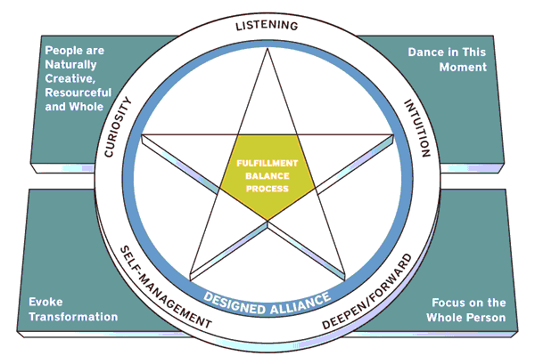

**People are Naturally Creative, Resourceful & Whole DANCE IN THIS MOMENT**

**Research Research**

Maslow’s Actualizing Tendency Emergent Process

Appreciate Inquiry Improvisation

Strength Theory Complexity Theory

Mindfulness

**evoke transformation Focus on the Whole person**

**Supporting Research Supporting Research**

Immunity to ChangeBio-pyscho-social-spiritual Model

Pygmalion P.E.R.F.E.C.T Model

Broaden and Build Complexity Theory

Positivity 3.1